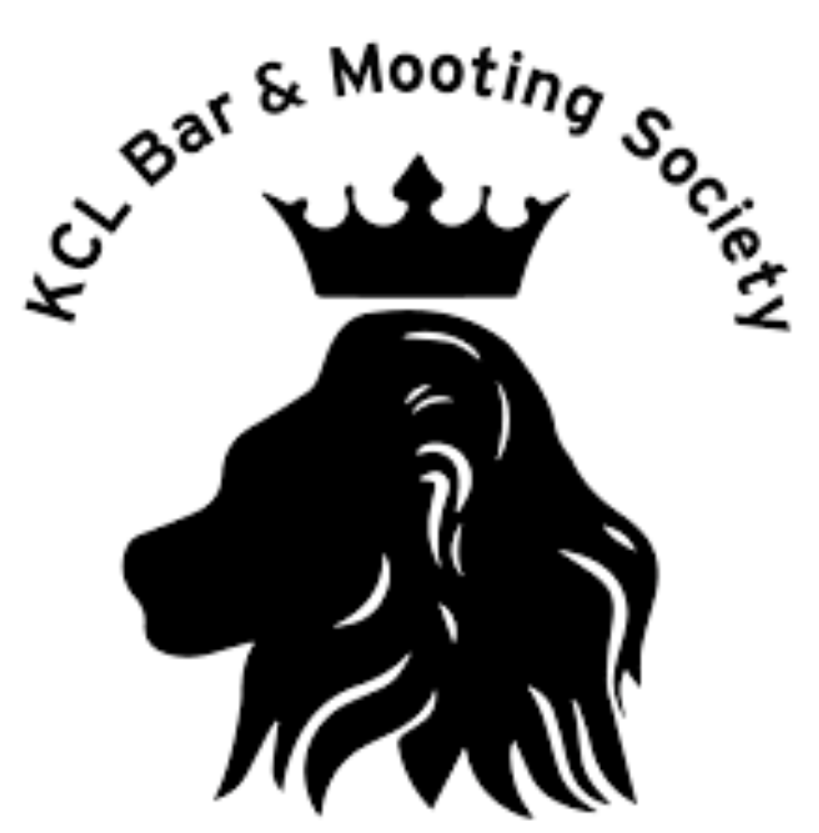
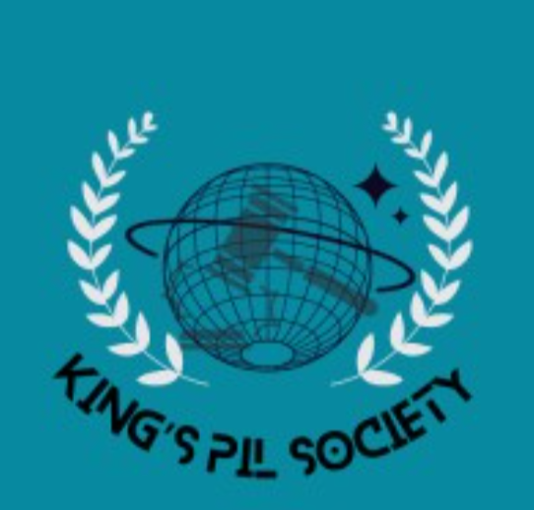

Kings College London Public International Law Society
and
Kings College London Bar and Mooting Society

Public International Law Moot Court

Moot Problem

Situation in the Kingdom of Betopia
In the case of

Morelli [Appellant]
v.
Camlen [Respondent]

Before the International Court of Justice at The Hague

Statement of Agreed Facts

- We are in 2040. The union of Betopia was created after the Celdonian war of 2030, which lasted for 288 days and led to the deaths of more than 10,000 individuals. Upon the end of that war between Celedon and countries which formed an alliance against Celedon, gave rise to the Union of Betopia. It comprises of 12 countries which include Morelli, Camlen, Queenfisher, Stiller and Cuiness. Most of the countries after the war took a democratic approach to establish governments in order to be consistent with the global world order wherein the presence of democracy was flourishing.

- Morelli is a country with a population of approximately 35 million people in the union of Betopia. The country is located on the coast of the Betopian Sea. The political dynamic of the country is currently dominated by the Henken party, A centre-right wing party which has been in power with a dominant majority since 2035. Due to the abundance of bops, a rare metal found in the crust of the earth, the economy of Morelli is dependent on this metal and the country is one of the leading countries in the world in the exportation of bops and hence has a stable and strong economy.

- Camlen is a small country of approximately 13 million people located in the Centre of the union of Betopia. Camlen shares its boundary with 5 out of the 11 countries within the union, including with Morelli. After the Celdonian war, Morelli faced internal issues such as corruption, increasing poverty and unemployment which also resulted in a high crime rate. The state failed to form a stable government until 2032, after which, Jasper Anheuser, the leader of the People’s Party of Camlen (PPC), was able to establish a government with a dominant majority of 88% with his campaign of ‘Reuniting Camlen as the centre of Betopia’. His nationalistic and country first approach led to the party being able to stay in power till 2038. Jasper amplified the performance of the economy by promoting a highly capitalistic regime which incentivised business and entrepreneurship.

- However, due to the approach taken by the PPC, the government has been heavily criticized by the people and by various independent think tanks worldwide for supporting monopolies in the countries major industries such as manufacturing and technology to high-earning tech and manufacturing industrialists. In 2037, the ministry of Micro, Small and Medium Enterprises (MSMEs) staged a boycott against the government of PPC. The situation only worsened with time as the income inequality grew to an all-time high, with the government attempting to shut down any attempts by the people of Camlen to voice the opinions by enacting the revised Camlen Penal Code (CPC) of 2038 which led to harsh penalties and lesser thresholds for sedition and hate speech, leading to increased arrests and detention of individuals. As a result of this, in the election of 2040, the CPC could not prove a majority in the parliament and a motion of no confidence was raised and passed, leaving the country in a state of anarchy.

- While the deterioration in Camlen exacerbated, certain citizens of Camlen picked up arms in order to show dissent against the CPC and PPC and created a revolutionary organization known as the Camlen Liberation Front (CLF). With increasing people distraught from the PPC’s treatment of its citizens, the group gained popularity and individuals who did not join the group, supported them. Notwithstanding multiple attempts, including the attempt by the PPC to render them a terrorist organization, the CLF were successful in overthrowing the PPC and established themselves as the de-facto leaders of Camlen.

- Concerned about the potential restrictions and punitive measures which Camlen may endure, the United Nations Security Council released a communique to voice their dissent regarding the coup-d’état organised by the CLF.

The Communique reads as follows:

United Nations Security Council Communiqué

Date: 24th May 2040
Subject: Condemnation of Violent Overthrow of Government in Camlen.

The United Nations Security Council convened on 24th May 2040 to discuss the recent events in the country of Camlen, where a violent overthrow of the government has taken place. The Security Council expresses its grave concern over the use of violent measures to seize power, which undermines the principles of democracy, peace, and stability that the United Nations upholds.

The Security Council members condemned in the strongest terms the actions of those responsible for orchestrating and carrying out the violent overthrow. They emphasized that any change of government should take place through peaceful, democratic, and lawful means, respecting the rule of law, human rights, and the will of the people.

The Council reiterated its commitment to the Charter of the United Nations, which emphasizes the importance of maintaining international peace and security, and stressed the necessity of resolving disputes through peaceful negotiations. The use of violence to achieve political goals is in direct contradiction to these fundamental principles.

In light of the situation in Camlen, the Security Council:
- Strongly Condemns: The violent overthrow of the legitimate government of Camlen and any acts of violence committed during the process.
- Calls For: An immediate cessation of hostilities and violence, and a peaceful resolution of the political crisis through dialogue, negotiations, and respect for the democratic process.
- Urges: All parties involved to exercise restraint and to prioritize the welfare and rights of the Camlonian people.
- Reaffirms: The importance of upholding human rights, including freedom of expression, assembly, and the right to participate in the political process without fear of reprisals.
- Encourages: The international community to support efforts towards a peaceful resolution, including through diplomatic engagement and mediation, as appropriate.

The Security Council remains seized of the matter and stands ready to take further action to address the situation in Camlen, should the need arise. The Security council does not recognise the CLF as an official government body considering revolutionary rise to power. The international community, under the auspices of the United Nations, reaffirms its commitment to promoting peace, security, and democratic governance, and expresses solidarity with the people of Camlen during this challenging period.

The Security Council emphasizes that those responsible for the violent overthrow and any violations of human rights and international law will be held accountable, and underscores the importance of adhering to the principles of justice and accountability.

The Security Council calls upon all member states to cooperate fully with the international community's efforts to restore stability and democracy to Camlen and to uphold the principles enshrined in the United Nations Charter.

[Signature]
President of the United Nations Security Council

7. The condemnation of the coup led to an increased threat of countries imposing economic sanctions and trade barriers on Camlen, and an increased risk of isolation of Betopia from the rest of the world. As a result, the neighbouring countries to Camlen increased border security amongst other measures to prevent illegal immigration of Camlonian people to their countries. In response to the communique by the UNSC, the leader of the CLF, Elvish Zabreen, organised a press conference.

Press Release:

From the Desk of Elvish Zabreen, Leader of the People’s Party of Camlen

Date: 26th May
Subject: Charting a New Path for Camlen

Dear Citizens of Camlen and Friends Around the World,

Today marks a new dawn for our beloved Camlen. The Camlen Liberation Front has successfully undertaken a historic revolution to bring about meaningful change, rooted in the aspirations of our people. With a deep sense of responsibility and determination, I address you in this momentous time to share our vision and intentions for the future.

The path we have taken to attain power was not without sacrifice and challenge. We recognize the concerns that have arisen due to the nature of our revolution. In the face of these concerns, the CLF reiterates its unwavering commitment to democratic values, human rights, and the rule of law. We stand ready to work with the international community to address any apprehensions, ensuring that our actions are aligned with global norms and standards.

In the spirit of inclusivity and the democratic ideals that fuel our movement, the CLF is proud to announce our decision to hold a national election. Our aim is to grant every citizen the opportunity to have their voices heard, to elect their representatives, and to shape the future of our nation. We believe that the best way to move forward and solidify the legitimacy of our governance is through the democratic will of the people.

We extend an invitation to international observers, institutions, and organizations to monitor and oversee the electoral process. This transparency demonstrates our commitment to upholding democratic principles and garnering the trust of our global partners. We specially invite delegates from the Union of Betopia to understand the priority we give to trade, economy and solidarity in our election manifestos.

The challenges facing Camlen is not unique, and we recognize the interconnectedness of the world. Our intentions extend beyond our borders, as we seek to collaborate with nations worldwide to address global threats, such as climate change, terrorism, and economic disparity. We are eager to engage in diplomatic efforts, fostering a culture of cooperation and mutual respect.

We understand that the road ahead is demanding, and it requires the collective efforts of all citizens. The CLF envisions a nation where prosperity, justice, and opportunity are accessible to everyone, regardless of background or circumstance. We are committed to building a future that ensures the well-being and progress of our people.

As we embark on this transformative journey, I call upon every citizen of Camlen to participate actively in shaping our nation's destiny. Let us come together, transcending differences, to create a brighter tomorrow. With a sense of unity and purpose, there is no limit to what we can achieve.

Thank you, and may the dawn of our new era be marked by peace, progress, and prosperity.

Sincerely,

Elvish Zabreen
Leader, Camlen Liberation Front

8. The national elections of Camlen were to be held in the October of 2040. In July, a conference organised by the CLF in Camlen was established in order to determine the possibility of an unbiased election which focuses on the democratic will of the Camlonian citizens. During the three day conference, diplomats from all over the world including the Union of Betopia and Morelli were invited to discuss the elements of the proposed election in the end of the year.

9. Nohana Takreem is the official United Nations ambassador to the Republic of Morelli. As the conference commenced, Nohana Takreem's presence was a beacon of diplomacy and collaboration. She engaged in discussions with fellow diplomats, advocates, and government officials, all to seek common ground and sustainable solutions. Nohana was outspoken about her support of the CLF not having the resources to hold a candid election and that the United Nations should play an active role in organising and conducting elections.

10. Amid the conference's sessions, Nohana Takreem's interactions with Camlonian officials revealed veiled threats and subtle attempts at intimidation. Next morning, Ambassador Takreem was absent from the scheduled conference sessions. The Camlonian authorities provided vague explanations for her absence, attributing it to unforeseen circumstances. Amidst the backdrop of the conference's discussions, it was revealed that the ambassador had been last seen engaging in what appeared to be routine conversations with high-ranking CLF officers. These interactions, upon closer scrutiny, appeared fraught with tension and unspoken threats.

11. As international pressure mounted, the Camlonian authorities acknowledged that Ambassador Takreem's whereabouts were unknown. The next morning, conspiracy grew louder, with insinuations that elements within the Camlonian government were involved in her disappearance by other high-ranking officials within the conference. Calls for transparency and a thorough investigation resonated across the world.

12. In the wake of the ambassador’s disappearance, Morelli demanded a thorough investigation, appropriate legal action, and cooperation from Camlen. Camlen, due to the condition of the present leadership, did not have the adequate resources, considering the absence of a stable government system and priority being given to the allocation of resources towards the conference and the upcoming national election. Elvish Zabreen said in a press conference ‘It is very unfortunate what has happened, the community along with our front are using all the resources at our disposal to find the ambassador of our ally and member of Betopia, Morelli’.

13. After one week of investigations and no significant input or leads regarding the disappearance of Nohana Takreem, the Morellian Government released the following statement:

Despite our earnest requests for cooperation and a proper investigation, the Camlonian authorities have been uncooperative and have denied us the opportunity to participate in efforts to locate Ms. Takreem. We have encountered resistance at every turn, making it increasingly apparent that there might be elements within the Camlonian government who are complicit in her disappearance.

Given the gravity of the situation and our steadfast commitment to safeguarding the welfare of our diplomats, we have been left with no choice but to explore alternative means to uncover the truth. Our intelligence suggests the possibility of a connection to a person with information related to Ms.Takreem’s disappearance who has ties to Morelli. This individual is known as Zila Akreem, amongst his other aliases, and is a Camlonian citizen residing in Morelli for the past 12 indefinitely. He has not resided anywhere else except in Morelli.

In light of this, we have taken decisive steps to apprehend this individual and bring them to a secure location for questioning. It is essential to note that we remain committed to respecting all legal and ethical standards during our pursuit of information. However, the urgency of the situation has compelled us to employ necessary measures to ensure the safety of our diplomat and uncover the truth behind her disappearance.

We want to emphasise that our priority is to locate Ms. Nohana and ensure her safe return. We will continue to exhaust all diplomatic channels to engage with the Camlonian government and find a peaceful resolution to this matter. Nevertheless, we must stress that we will not hesitate to take further actions, should the need arise, to secure the well-being of our diplomat and to hold those responsible for her disappearance accountable.

Please be assured that we are handling this situation with the utmost care and consideration for both diplomatic norms and the well-being of all parties involved. We will keep you updated on any developments as they unfold.

14. Human rights organisations are distraught at the attempt by the government to detain an individual indefinitely without publicly releasing the evidence which has led to the arrest of Zila Akreem. After a week of detention, a statement is released by Zila Akreem to a human rights organisation blaming the Morellian government of subjecting him to torture and other punitive punishments. Morelli denies all accusations of torture and maintains that he is being held for questioning as he is the ‘critical’ suspect who the Morellian government believe is involved in the disappearance of Nohana Takreem. The statement of Zila Akreem reads as follows.

I, Zila Akreem, hereby make this statement under duress and against my will. I am currently being held in an undisclosed location by Morelli authorities, who have subjected me to inhumane and punitive treatment. I wish to assert my innocence regarding the disappearance of the Morellian diplomat.

I acknowledge that I have travelled frequently between Morelli and Camlen, fostering close ties with individuals associated with the Camlen Liberation Front (CLF). I have, in the past, engaged in activities that aided the CLF, including participating in operations of a violent nature, for monetary gain. However, I emphasize that I have not played any role in the disappearance of Nohana Takreem, the diplomat from Morelli.

The claims that I possess information relevant to Ms. Nohana disappearance are utterly false. I am a victim of unjust circumstances, having been taken from my home under the guise of Morelli authorities. My subsequent treatment has been marked by torture and threats, as individuals seek to extract information that I do not possess.

I reiterate that my involvement with the CLF was limited to financial incentives and, to my knowledge, did not extend to acts that would lead to the disappearance of diplomats. I categorically deny any wrongdoing in relation to this case and assert that I have no knowledge or participation in his situation.

I am reaching out to the international community, human rights organizations, and diplomatic missions, pleading for assistance in securing my safety and ensuring that justice is served. My life hangs in the balance due to the actions of those who unlawfully detained me and have subjected me to heinous treatment.

I demand that a thorough and impartial investigation be conducted into both my detention and the circumstances surrounding the disappearance. I implore that my rights be respected, that I am granted access to legal representation, medical care, and contact with my family.

I stand by my assertion of innocence in the disappearance of Nohana Takreem, and I fervently request that those responsible for my unwarranted detainment cease their actions and uphold the principles of justice, human rights, and the rule of law.

Zila Akreem

15. Two weeks after the statement was uncovered, Camlen requested that the dispute between the parties be resolved through arbitration. Morelli actively refused to have the dispute settled by any tribunal, demanding that the International Court of Justice was the only appropriate forum. After six months had passed, Morelli decided to rely on Article 30 of the Convention Against Torture to bring the dispute before the International Court of Justice.

16. Camlen and Morelli have at all relevant times been parties to the United Nations Charter, the Statute of the International Court of Justice, the Vienna Convention on the Law of the Treaties (VCLT), the International Covenant on Civil and Political Rights (ICCPR), the International Covenant on Economic, Social and Cultural Rights (ICESCR), the Vienna Convention on Diplomatic Relations (VCDR), the Convention for Protection of all Persons from Enforced Disappearance, and the Convention against Torture. Both Camlen and Morelli have made Optional Declarations under Article 36(2) of the ICJ Statute.

On the basis of the foregoing Agreed Statement of Facts, Morelli requests the International Court of Justice to adjudge and declare that:
- The CLF coup-d’état does not have democratic legitimacy as it is unrecognized by other states including Morelli and the coup is in violation of Camlen’s sovereignty pursuant to the United Nations Charter, The International Covenant on Civil and Political Rights (ICCPR) and The International Covenant on Economic, Social, and Cultural Rights (ICESCR).

- Pursuant to illegitimacy, the actions of the CLF regarding the disappearance of the diplomatically immune Nohana Takreem are in violation of the Convention for Protection of all Persons from Enforced Disappearance and the Vienna Convention on Diplomatic Relations.

In response to the claim, Camlen contends and counterclaims that:

- The actions of the current Camlonian government [CLF] are in interest and pursuant to the right of self-determination, in accordance with the United Nations Charter and the International Covenant on Civil and Political Rights.

- The Morellian governments actions against Zila Akreem constitute a material breach of their obligations under the Vienna Convention on the Law of Treaties and the Convention against torture.

Written By Shiven Widhani [LLB’25]

